# 

**Question 3 - What is IL code and Questions 4 - Why do we need JIt? And why need to convert first into IL code**

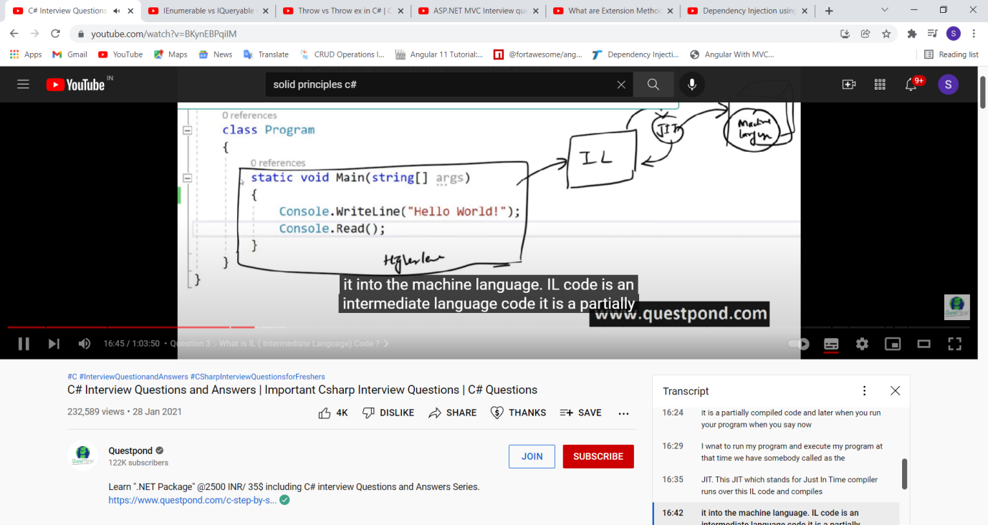

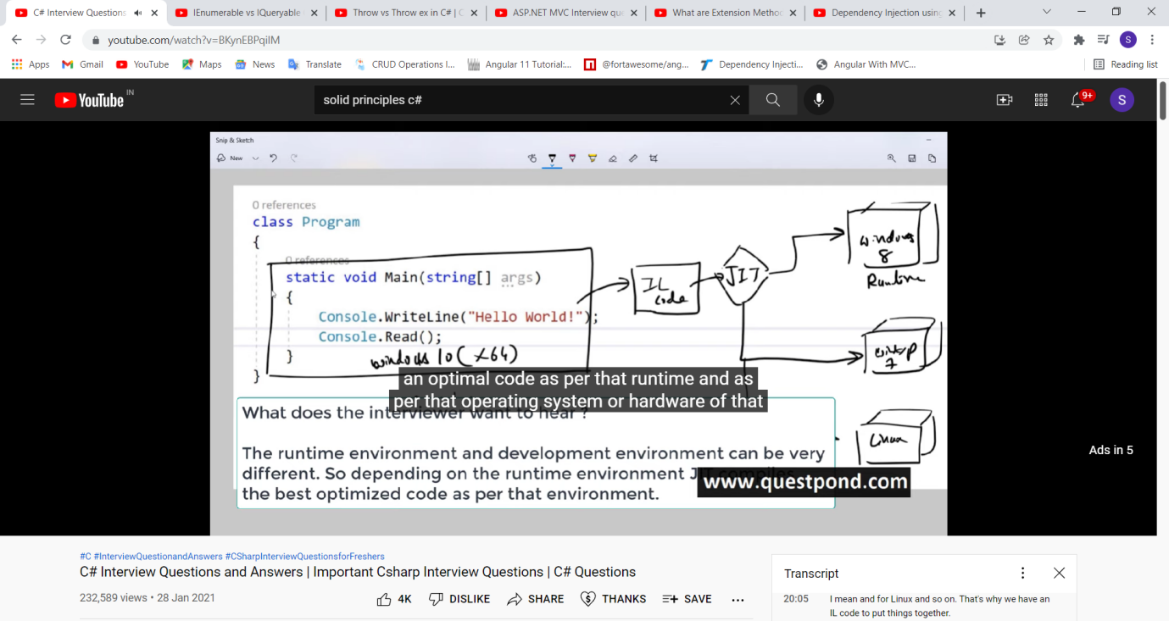

Need of IL=>because development and runtime env. /OS may be different

What clr do?

It run the appl.

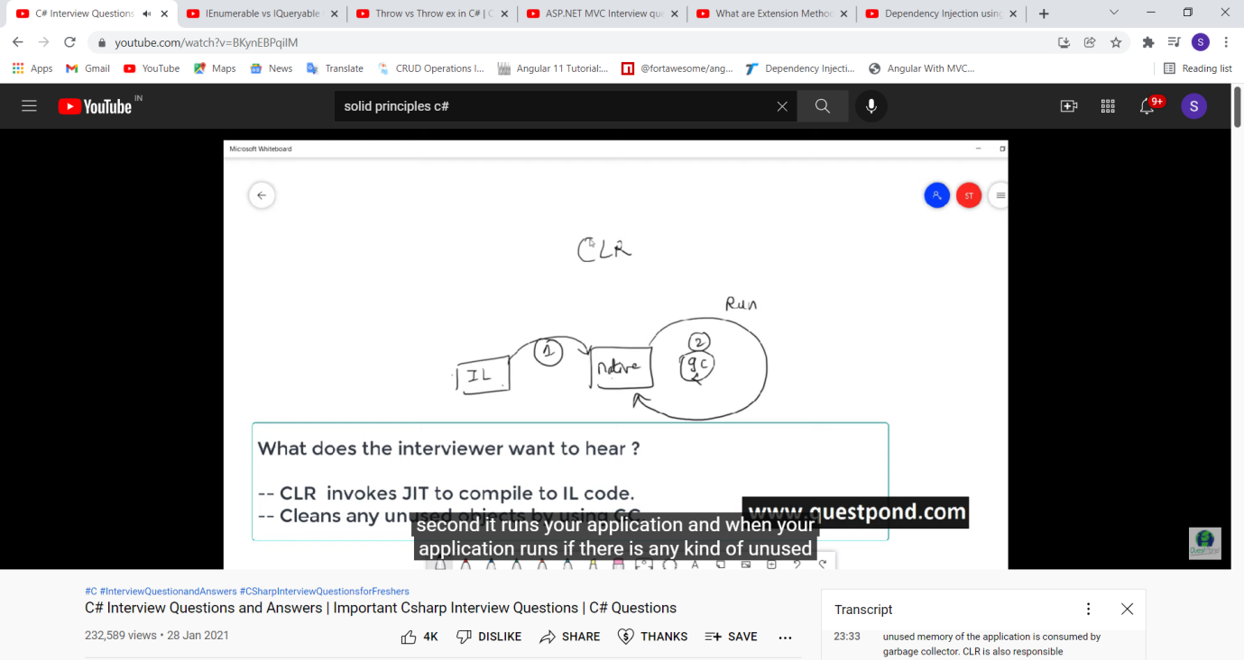

# Garbage Collection

Automatic memory management is made possible by **Garbage Collection in .NET Framework**. When a class object is created at runtime, certain memory space is allocated to it in the heap memory. However, after all the actions related to the object are completed in the program, the memory space allocated to it is a waste as it cannot be used. In this case, garbage collection is very useful as it automatically releases the memory space after it is no longer required.   
Garbage collection will always work on **Managed Heap** and internally it has an Engine which is known as the **Optimization Engine**.   
Garbage Collection occurs if at least one of multiple conditions is satisfied. These conditions are given as follows:

* If the system has low physical memory, then garbage collection is necessary.
* If the memory allocated to various objects in the heap memory exceeds a pre-set threshold, then garbage collection occurs.
* If the *GC.Collect* method is called, then garbage collection occurs. However, this method is only called under unusual situations as normally garbage collector runs automatically.

#### Phases in Garbage Collection

There are mainly **3** phases in garbage collection. Details about these are given as follows:



1. **Marking Phase:** A list of all the live objects is created during the marking phase. This is done by following the references from all the root objects. All of the objects that are not on the list of live objects are potentially deleted from the heap memory.
2. **Relocating Phase:** The references of all the objects that were on the list of all the live objects are updated in the relocating phase so that they point to the new location where the objects will be relocated to in the compacting phase.
3. **Compacting Phase:** The heap gets compacted in the compacting phase as the space occupied by the dead objects is released and the live objects remaining are moved. All the live objects that remain after the garbage collection are moved towards the older end of the heap memory in their original order.



**Managed code** is the code which is managed by the CLR(Common Language Runtime) in *.NET Framework*. Whereas the Unmanaged code is the code which is directly executed by the operating system. Below are some important differences between the Managed code and Unmanaged code:

| Managed Code | Unmanaged Code |
| --- | --- |
| It is executed by managed runtime environment or managed by the CLR. | It is executed directly by the operating system. |
| It provides security to the application written in .NET Framework. | It does not provide any security to the application. |
| Memory buffer overflow does not occur. | Memory buffer overflow may occur. |
| It provide runtime services like Garbage Collection, exception handling, etc. | It does not provide runtime services like Garbage Collection, exception handling, etc. |
| The source code is compiled in the intermediate language known as *IL or MSIL or CIL*. | The source code directly compiles into native languages. |
| It does not provide low-level access to the programmer. | It provide low-level access to the programmer. |

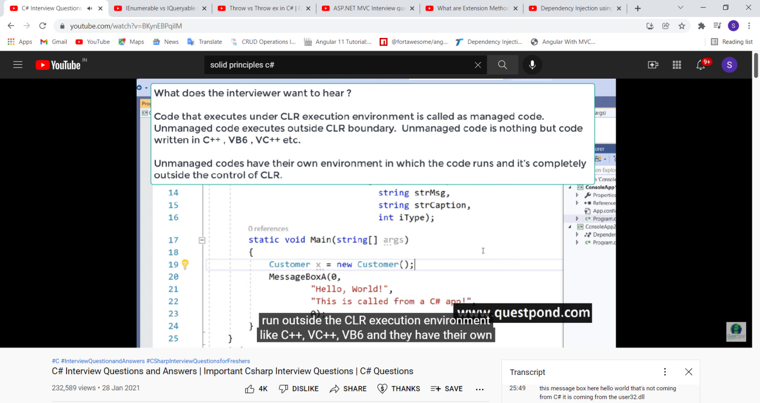

**CTS=>Common type system**

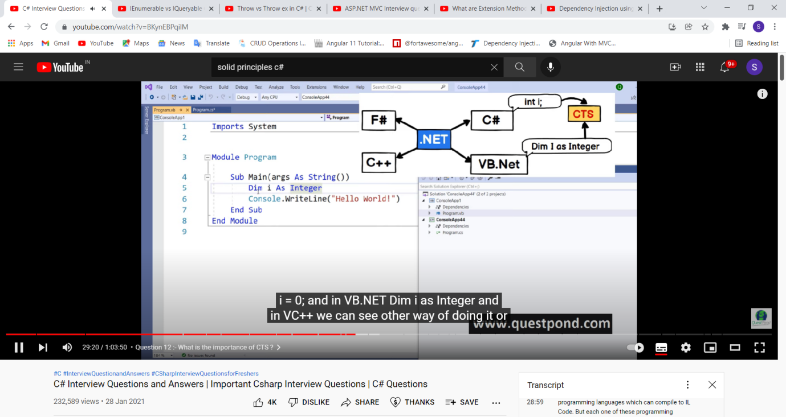



**CLS=>common lang. specification**

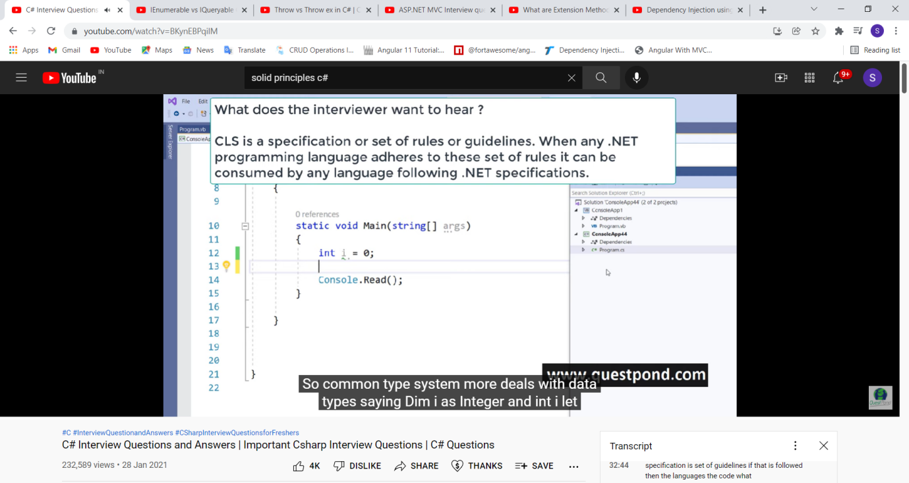

**Stack vs heap**

memory types one is a stack and another one is a heap. On stack primitive data types are allocated means data types like integer, boolean, double, decimal. These data types get allocated on the stack and on the stack the variable and the value both are stored at the same place. For example you can see the first statement int i = 10;

in heap objects store

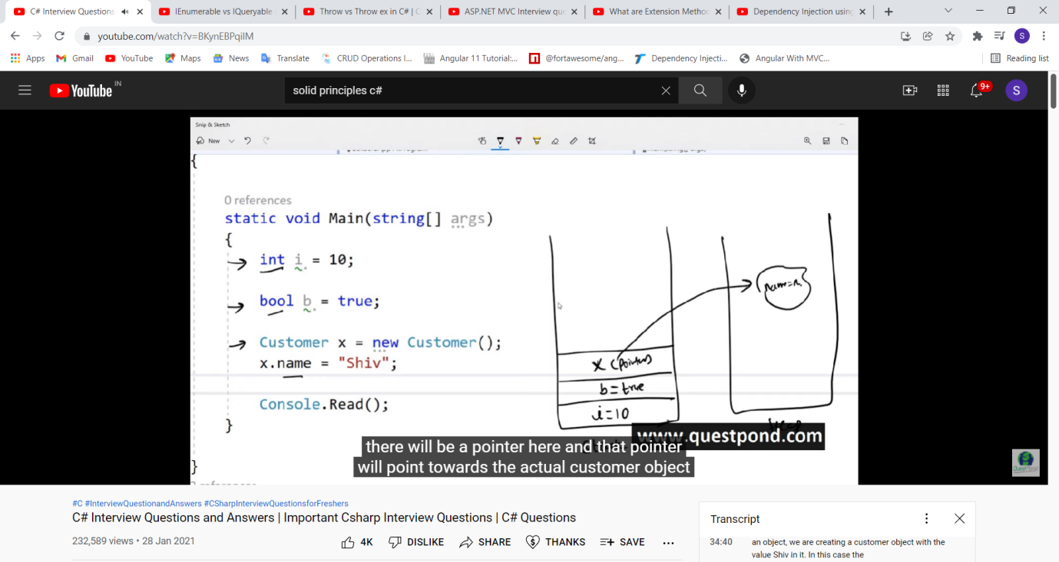

**Value and reference type:**

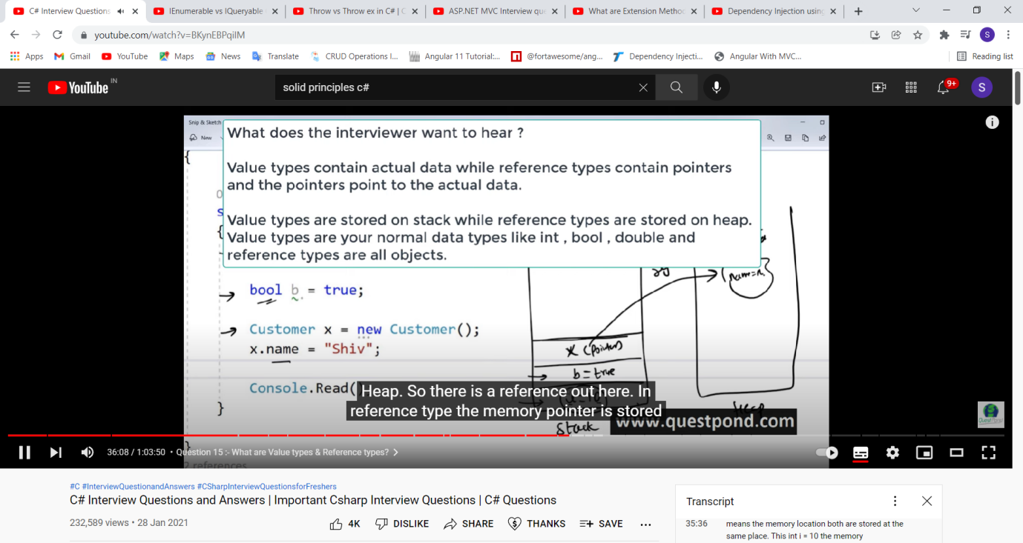

**Boxing vs unboxing**

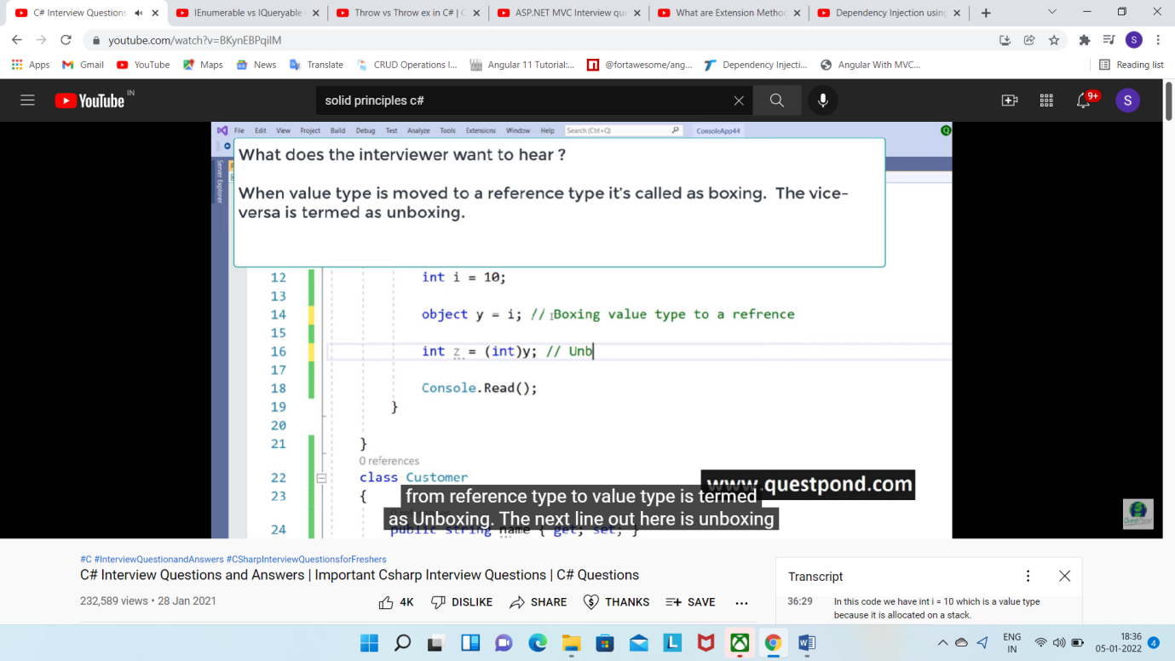

**Array vs ArrayList**

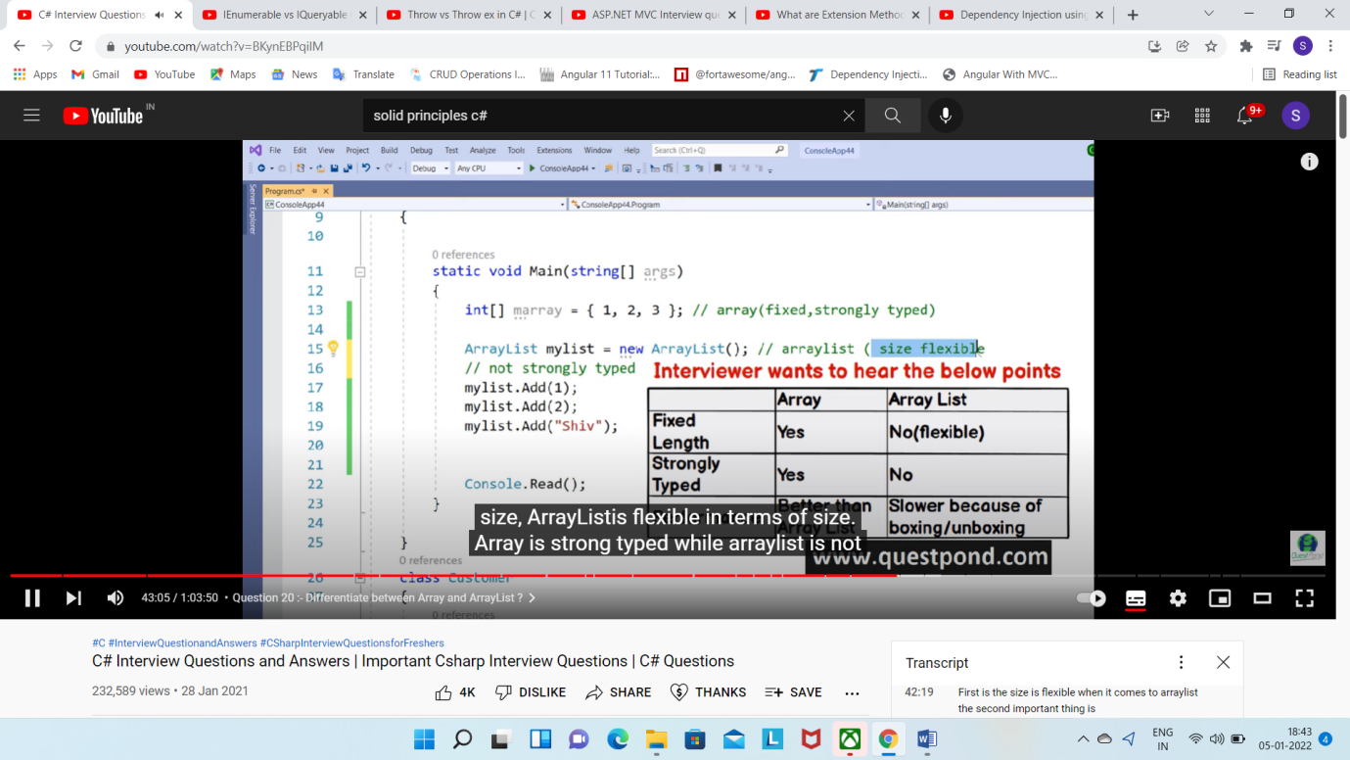

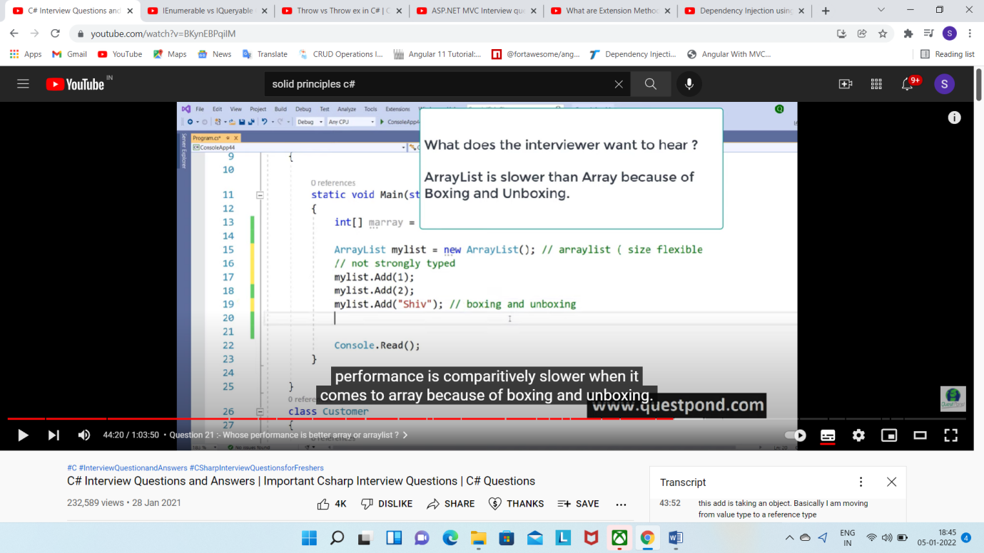

**Generic collection?**

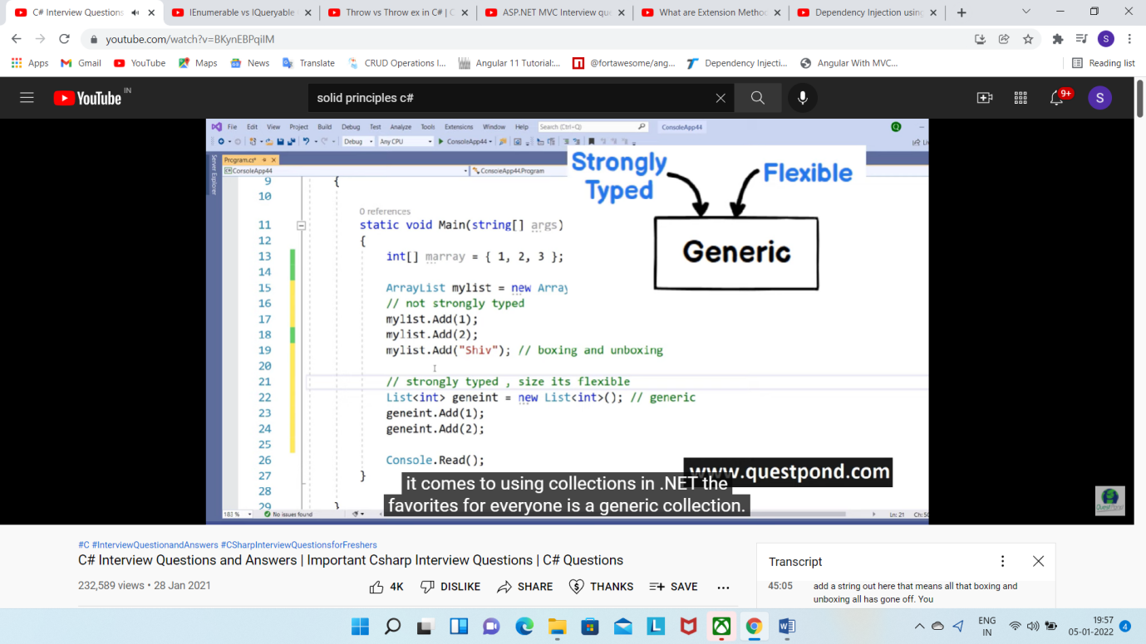

**Thread vs task?**

TPL=>Task parallel library

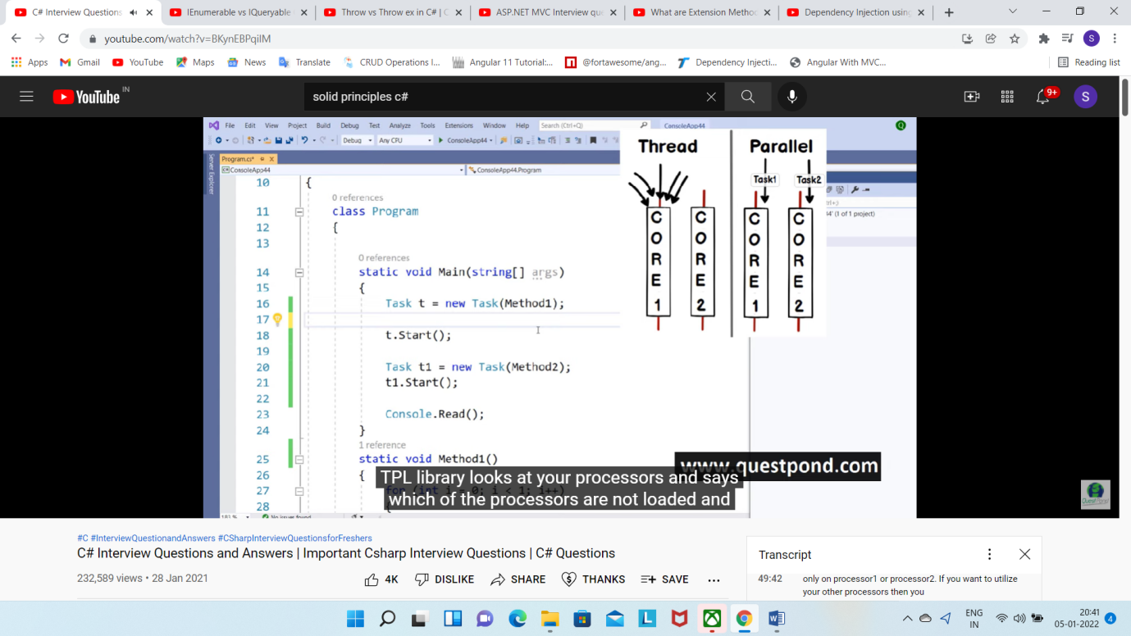



TASK for parallel processing=>it utilize processor fully and hardware, come in 4.x versions

But thread not properly use processor,use only one processor, use in old code

**What are events?**

Events are wrapper over delegates, they are encapsulation over delegates. They ensure delegates cannot be tempered by anyone. Events change the delegates to a publisher subscriber model.

**Throw vs throw ex**

Throw ex reset the stack trace

But throw maintain the stack trace, where exception originate etc

# Encapsulation

Encapsulation is defined as the wrapping up of data under a single unit. It is the mechanism that binds together code and the data it manipulates. In a different way, encapsulation is a protective shield that prevents the data from being accessed by the code outside this shield.

* Technically in encapsulation, the variables or data of a class are hidden from any other class and can be accessed only through any member function of own class in which they are declared.
* As in encapsulation, the data in a class is hidden from other classes, so it is also known as **data-hiding**.
* **Encapsulation can be achieved by:** Declaring all the variables in the class as private and using [C# Properties](https://www.geeksforgeeks.org/c-properties/) in the class to set and get the values of variables.

**Example:**

|  |
| --- |
| // C# program to illustrate encapsulation  using System;  public class DemoEncap {      // private variables declared      // these can only be accessed by      // public methods of class      private String studentName;      private int studentAge;        // using accessors to get and      // set the value of studentName      public String Name      {            get          {              return studentName;          }            set          {              studentName = value;          }        }        // using accessors to get and      // set the value of studentAge      public int Age      {            get          {              return studentAge;          }            set          {              studentAge = value;          }        }      }    // Driver Class  class GFG {        // Main Method      static public void Main()      {            // creating object          DemoEncap obj = new DemoEncap();            // calls set accessor of the property Name,          // and pass "Ankita" as value of the          // standard field 'value'          obj.Name = "Ankita";            // calls set accessor of the property Age,          // and pass "21" as value of the          // standard field 'value'          obj.Age = 21;            // Displaying values of the variables          Console.WriteLine("Name: " + obj.Name);          Console.WriteLine("Age: " + obj.Age);      }  } |

* **Output:**
* Name: Ankita
* Age: 21

**Advantages of Encapsulation:**

* **Data Hiding:** The user will have no idea about the inner implementation of the class. It will not be visible to the user that how the class is stored values in the variables. He only knows that we are passing the values to accessors and variables are getting initialized to that value.
* **Increased Flexibility:** We can make the variables of the class as read-only or write-only depending on our requirement. If we wish to make the variables as read-only then we have to only use Get Accessor in the code. If we wish to make the variables as write-only then we have to only use Set Accessor.
* **Reusability:** Encapsulation also improves the re-usability and easy to change with new requirements.
* **Testing code is easy:**Encapsulated code is easy to test for unit testing.

# Abstraction

In C# abstraction is achieved with the help of **Abstract classes**.

Data Abstraction is the property by virtue of which only the essential details are exhibited to the user. The trivial or the non-essentials units aren’t exhibited to the user.   
Data Abstraction may also be defined as the process of identifying only the required characteristics of an object ignoring the irrelevant details. The properties and behaviors of an object differentiate it from other objects of similar type and also help in classifying/grouping the objects.

**Example:** Consider a real-life scenario of withdrawing money from ATM. The user only knows that in ATM machine first enter ATM card, then enter the pin code of ATM card, and then enter the amount which he/she wants to withdraw and at last, he/she gets their money. The user does not know about the inner mechanism of the ATM or the implementation of withdrawing money etc. The user just simply knows how to operate the ATM machine, this is called abstraction.

|  |
| --- |
| **Example:**  // C# program to calculate the area  // of a square using the concept of  // data abstraction  using System;    namespace Demoabstraction {    // abstract class  abstract class Shape {        // abstract method      public abstract int area();  }    // square class inheriting  // the Shape class  class Square : Shape {        // private data member      private int side;        // method of  square class      public Square(int x = 0)      {          side = x;      }        // overriding of the abstract method of Shape      // class using the override keyword      public override int area()      {          Console.Write("Area of Square: ");          return (side * side);      }  }  // Driver Class  class GFG {        // Main Method      static void Main(string[] args)      {            // creating reference of Shape class          // which refer to Square class instance          Shape sh = new Square(4);            // calling the method          double result = sh.area();            Console.Write("{0}", result);        }  }  } |

**Output:**

Area of Square: 16

### Encapsulation vs Data Abstraction

* [**Encapsulation**](https://www.geeksforgeeks.org/c-encapsulation/)is data hiding(information hiding) while Abstraction is detail hiding(implementation hiding).
* While encapsulation groups together data and methods that act upon the data, data abstraction deal with exposing to the user and hiding the details of implementation.

### Advantages of Abstraction

* It reduces the complexity of viewing things.
* Avoids code duplication and increases reusability.
* Helps to increase the security of an application or program as only important details are provided to the user.

### Private Constructor

If a constructor is created with private specifier is known as Private Constructor. It is not possible for other classes to derive from this class and also it’s not possible to create an instance of this class.

**Points To Remember :**

* It is the implementation of a singleton class pattern.
* use private constructor when we have only static members.
* Using private constructor, prevents the creation of the instances of that class.

**Example :**

|  |
| --- |
| // C# Program to illustrate calling  // a Private constructor  usingSystem;  namespaceprivateConstructorExample {    publicclassGeeks {        // declare private Constructor      privateGeeks()      {      }        // declare static variable field      publicstaticintcount_geeks;        // declare static method      publicstaticintgeeks_Count()      {          return++count_geeks;      }        // Main Method      publicstaticvoidMain()      {            // If you uncomment the following          // statement, it will generate          // an error because the constructor          // is unaccessible:          // Geeks s = new Geeks(); // Error            Geeks.count_geeks = 99;            // Accessing without any          // instance of the class          Geeks.geeks_Count();            Console.WriteLine(Geeks.count_geeks);            // Accessing without any          // instance of the class          Geeks.geeks_Count();            Console.WriteLine(Geeks.count_geeks);      }  }  } |

**Output :**

100

101

### Static Constructor

Static Constructor has to be invoked only once in the class and it has been invoked during the creation of the first reference to a static member in the class. A static constructor is initialized static fields or data of the class and to be executed only once.

**Points To Remember :**

* It can’t be called directly.
* When it is executing then the user has no control.
* It does not take access modifiers or any parameters.
* It is called automatically to initialize the class before the first instance created.

**Example :**

|  |
| --- |
| // C# Program to illustrate calling  // a Static constructor  using System;  namespace staticConstructorExample {    class geeks {        // It is invoked before the first      // instance constructor is run.      static geeks()      {            // The following statement produces          // the first line of output,          // and the line occurs only once.          Console.WriteLine("Static Constructor");      }        // Instance constructor.      public geeks(int i)      {          Console.WriteLine("Instance Constructor " + i);      }        // Instance method.      public string geeks_detail(string name, int id)      {          return "Name:" + name + " id:" + id;      }        // Main Method      public static void Main()      {            // Here Both Static and instance          // constructors are invoked for          // first instance          geeks obj = new geeks(1);            Console.WriteLine(obj.geeks_detail("GFG", 1));            // Here only instance constructor          // will be invoked          geeks obj1 = new geeks(2);            Console.WriteLine(obj1.geeks_detail("GeeksforGeeks", 2));      }  }  } |

**Output :**

Static Constructor

Instance Constructor 1

Name:GFG id:1

Instance Constructor 2

Name:GeeksforGeeks id:2

# Destructors in C#

Destructors in C# are methods inside the class used to destroy instances of that [class](https://www.geeksforgeeks.org/c-class-and-object/)when they are no longer needed. The Destructor is called implicitly by the [.NET Framework’s](https://www.geeksforgeeks.org/introduction-to-net-framework/) Garbage collector and therefore programmer has no control as when to invoke the destructor. An instance variable or an object is eligible for destruction when it is no longer reachable.

**Important Points:**

* A Destructor is unique to its class i.e. there cannot be more than one destructor in a class.
* A Destructor has no return type and has exactly the same name as the class name (Including the same case).
* It is distinguished apart from a [constructor](https://www.geeksforgeeks.org/c-sharp-constructors/)because of the *Tilde symbol (~)* prefixed to its name.
* A Destructor does not accept any parameters and modifiers.
* It cannot be defined in Structures. It is only used with classes.
* It cannot be overloaded or inherited.
* It is called when the program exits.
* Internally, Destructor called the Finalize method on the base class of object.

**Syntax:**

class Example

{

// Rest of the class

// members and methods.

// Destructor

~Example()

{

// Your code

}

}

|  |
| --- |
| // a destructor works  using System;    namespace GeeksforGeeks {    class Complex {        // Class members, private      // by default      int real, img;        // Defining the constructor      public Complex()      {          real = 0;          img = 0;      }        // SetValue method sets      // value of real and img      public void SetValue(int r, int i)      {          real = r;          img = i;      }        // DisplayValue displays      // values of real and img      public void DisplayValue()      {          Console.WriteLine("Real = " + real);          Console.WriteLine("Imaginary = " + img);      }        // Defining the destructor      // for class Complex      ~Complex()      {          Console.WriteLine("Destructor was called");      }    } // End class Complex      // Driver Class  class Program {        // Main Method      static void Main(string[] args)      {            // Creating an instance of class          // Complex C invokes constructor          Complex C = new Complex();            // Calling SetValue method using          // instance C Setting values of          // real to 2 and img to 3          C.SetValue(2, 3);            // Displaying values of real          // and imaginary parts          C.DisplayValue();            // Instance is no longer needed          // Destructor will be called        } // End Main    } // End class Program    } |

**Output:**

Real = 2

Imaginary = 3

Destructor was called

# C# | Type Casting

Type conversion happens when we assign the value of one data type to another. If the data types are compatible, then [C#](https://www.geeksforgeeks.org/introduction-to-c-sharp/) does **Automatic Type Conversion**. If not comparable, then they need to be converted explicitly which is known as **Explicit Type conversion**. For example, assigning an int value to a long variable.

It happens when:

* The two data types are compatible.
* When we assign value of a smaller data type to a bigger data type.

**Following table shows the implicit types of conversion that is supported by C# :**

|  |  |
| --- | --- |
| Convert from Data Type | Convert to Data Type |
| Byte | short, int, long, float, double |
| Short | int, long, float, double |
| Int | long, float, double |
| Long | float, double |
| Float | Double |

**Example :**

|  |
| --- |
| // C# program to demonstrate the  // Implicit Type Conversion  usingSystem;  namespaceCasting{    classGFG {            // Main Method          publicstaticvoidMain(String []args)          {              inti = 57;                // automatic type conversion              longl = i;                // automatic type conversion              floatf = l;                // Display Result              Console.WriteLine("Int value "  +i);              Console.WriteLine("Long value "  +l);              Console.WriteLine("Float value "  +f);          }  }  } |

**Output:**

Int value 57

Long value 57

Float value 57

**Explicit Type Casting**

There may be compilation error when types not compatible with each other. For example, assigning double value to int data type:

|  |
| --- |
| // C# program to illustrate incompatible data  // type for explicit type conversion  usingSystem;  namespaceCasting{    classGFG {            // Main Method          publicstaticvoidMain(String []args)          {              doubled = 765.12;                // Incompatible Data Type              inti = d;                // Display Result              Console.WriteLine("Value of i is ", +i);          }  }  } |

**Error :**

prog.cs(14,21): error CS0266: Cannot implicitly convert type `double' to `int'.

An explicit conversion exists (are you missing a cast?)

So, if we want to assign a value of larger data type to a smaller data type we perform explicit type casting.

* This is useful for incompatible data types where automatic conversion cannot be done.
* Here, target-type specifies the desired type to convert the specified value to.
* Sometimes, it may result into the **lossy conversion.**

**Example :**

|  |
| --- |
| // C# program to demonstrate the  // Explicit Type Conversion  usingSystem;  namespaceCasting{    classGFG {            // Main Method          publicstaticvoidMain(String []args)          {              doubled = 765.12;                // Explicit Type Casting              inti = (int)d;                // Display Result              Console.WriteLine("Value of i is "+i);          }  }  } |

**Output:**

Value of i is 765

**Explanation :**  
Here due to lossy conversion, the value of i becomes 765 and there is a loss of 0.12 value.

#### C# provides built-in methods for Type-Conversions as follows :

|  |  |
| --- | --- |
| Method | Description |
| ToBoolean | It will converts a type to Boolean value |
| ToChar | It will converts a type to a character value |
| ToByte | It will converts a value to Byte Value |
| ToDecimal | It will converts a value to Decimal point value |
| ToDouble | It will converts a type to double data type |
| ToInt16 | It will converts a type to 16-bit integer |
| ToInt32 | It will converts a type to 32 bit integer |
| ToInt64 | It will converts a type to 64 bit integer |
| ToString | It will converts a given type to string |
| ToUInt16 | It will converts a type to unsigned 16 bit integer |
| ToUInt32 | It will converts a type to unsigned 32 bit integer |
| ToUInt64 | It will converts a type to unsigned 64 bit integer |

**Example :**

|  |
| --- |
| // C# program to demonstrate the  // Built- In Type Conversion Methods  usingSystem;  namespaceCasting{    classGFG {            // Main Method          publicstaticvoidMain(String []args)          {              inti = 12;              doubled = 765.12;              floatf = 56.123F;                // Using Built- In Type Conversion              // Methods & Displaying Result              Console.WriteLine(Convert.ToString(f));              Console.WriteLine(Convert.ToInt32(d));              Console.WriteLine(Convert.ToUInt32(f));              Console.WriteLine(Convert.ToDouble(i));              Console.WriteLine("GeeksforGeeks");          }  }  } |

**Output:**

56.123

765

56

12

GeeksforGeeks

# Indexers

An indexer allows an instance of a class or struct to be indexed as an array. If the user will define an indexer for a class, then the class will behave like a virtual array. Array access operator i.e (**[ ]**) is used to access the instance of the class which uses an indexer. A user can retrieve or set the indexed value without pointing an instance or a type member. Indexers are almost similar to the [**Properties**](https://www.geeksforgeeks.org/c-properties/).*The main difference between Indexers and*[*Properties*](https://www.geeksforgeeks.org/c-properties/) is that the [accessors](https://www.geeksforgeeks.org/c-properties/)of the Indexers will take parameters.

# **Var vs Dynamic**

Var – compiler decides the type at compile time. Eg: var a = 9.5 will make “a” as double.It was included in c# to handle special cases like LINQ.

Var can not be assigned null or used without initialization.

It can not be used for properties or returning values in a method.

It can not be used in method parameters.

Dynamic- compiler decides the type at run time.

Dynamic can be assigned null or used without initialization.

It can be used for properties or returning values in a function.

It can be used in method parameters.

# Readonly vs const:

Readonly can be assigned value in declaration or in constructor.

Const can be assigned value during declaration only and can not be reassigned whereas readonly can be reassigned in constructor of same class.

Readonly variable can not be declared inside a method whereas const can be declared inside a method.

Usage Wise difference

A const is a compile time constant whereas readonly is a runtime constant. This means that the value of const will always remain constant while writing the code however the value of readonly can be assigned at runtime and will remain constant until reinitialized again.

publicclassA

{

readonlystring str = "";

publicA()

{

str = "test";

Console.WriteLine(str);

}

publicA( string b)

{

str = b;

Console.WriteLine(st r);

}

}

staticvoid Main(string[] args)

{

A objA = new A();

objA = new A("testobj");

Console.ReadKey();

}

}

# Shallow vs DeepCopy:

When we assign one obj to another then obj is copied by reference.This means changes in one object will reflect in another. To overcome this problem DeepCopy is used.

publicclassShallowDeepCopy

{

publicint num { get; set; }

publicstring str { get; set; }

public ShallowDeepCopy Deepcopy(int num, string str)

{

ShallowDeepCopy sd = new ShallowDeepCopy();

sd.num = num;

sd.str = str;

return sd;

}

}

staticvoid Main(string[] args)

{

ShallowDeepCopy SD = new ShallowDeepCopy();

ShallowDeepCopy SD2 = new ShallowDeepCopy();

//shallow copy example

SD.num = 9;

SD.str = "test1";

SD2 = SD;

SD2.num = 12;

SD2.str = "test2";

Console.WriteLine("SD Data {0} and {1}", SD.num, SD.str);//Output: SD Data 12 and test2

Console.WriteLine("SD2 Data {0} and {1}", SD2.num, SD2.str);// Output: SD2 Data 12 and test2

//deep cpoy example

SD.num = 9;

SD.str = "test1";

SD2 = (ShallowDeepCopy)SD.Deepcopy(12, "test2");

SD2.num = 12;

SD2.str = "test2";

Console.WriteLine("SD Data {0} and {1}", SD.num, SD.str); Output: //SD Data 9 and test1

Console.WriteLine("SD2 Data {0} and {1}", SD2.num, SD2.str); Output: //SD2 Data 12 and test2

Console.ReadKey();

}

# Out vs ref

* Both out and ref pass arguments by reference. This means that memory address of variable is passed instead of its value hence any changes made are reflected in the value of parameter passed.
* ref is mandatory to initialize in caller method whereas out is mandatory to initialize in calling.
* Easy way to remember: ref is bidirectional which means its reference is passed from caller to

Calling and from calling to caller therefore it is required to initialize it in caller whereas out is unidirectional which means its reference is passed from calling to caller therefore it is required to initialize it in calling.

=>out also used to return multiple value from a method

publicstaticvoid OUTMethod(outstring a ) 🡺 Calling Method

{

a = "out method called"; 🡺 this initialization is mandatory for out

}

publicstaticvoid REFMethod(refstring a) 🡺 Calling Method

{

a = "ref method called";🡺 this initialization is not mandatory for ref

}

publicstaticvoid NormalMethod(string a) 🡺 Calling Method

{

a = "Normal Method";

}

staticvoid Main(string[] args)

{

string refParam="refParam" ;🡺 this initialization is mandatory for ref

string outParam; ;🡺 this initialization is not mandatory for out

string NormalParam = "normalParam";

OUTMethod(out outParam); 🡺 Caller Method

REFMethod(ref refParam); 🡺 Caller Method

NormalMethod(NormalParam);

Console.WriteLine("ref: {0}", refParam);

Console.WriteLine("out: {0}", outParam);

Console.WriteLine("normal: {0}", NormalParam);

Console.ReadKey();

//Output:

//ref: ref method called

//out: out method called

//normal: normalParam

}

**Out vs ref in method overloading:**

Out and ref method can not be overloaded however if one method does not have out and ref then the can be overloaded.

Eg.

classtest

{

publicvoid Method1(refint a)

{

Console.WriteLine("a");

}

publicvoid Method1(outint b)

{

b = 2;

Console.WriteLine("b");

}

}

The above code gives error “cannot define overloaded methods that differ only on ref and out.”

classtest

{

publicvoid Method1(refint a)

{

Console.WriteLine("a");

}

publicvoid Method1(int b)

{

b = 2;

Console.WriteLine("b");

}

}

The above code is error free and an example of method overloading with out/ref.

# Inheritance and Polymorphism:

**Inheritance:**

The ability of a class to inherit members, properties or methods of another class is called inheritance. Inheritance helps us achieve “is a” relationship. Eg every dog is an animal so dog class can access all public members of animal class.

classAnimal

{

publicstring AnimalType { get; set; }

publicvoid MakeSound()

{

Console.WriteLine("Every Animal Makes Sound");

}

}

classDog : Animal

{

publicvoid Pet()

{

Console.WriteLine("Dog is a pet animal");

}

}

staticvoid Main(string[] args)

{

Dog d = new Dog();

d.AnimalType = "Mammal";

d.MakeSound();

Console.ReadKey();

}

* When we instantiate a derived class, the base class gets instantiated automatically which means the default constructor of base class is called automatically.

Eg:

classAnimal

{

publicAnimal()

{

Console.WriteLine("I am an animal");

}

}

classDog : Animal

{

publicDog()

{

Console.WriteLine("I am a dog");

}

}

staticvoid Main(string[] args)

{

Dog d = new Dog();

Console.ReadKey();

}

Output:

I am an animal

I am a dog

* How to call another constructor of base class which is not a default constructor from derived class:

classAnimal

{

publicAnimal()

{

Console.WriteLine("I am an animal");

}

publicAnimal( string animalType)

{

Console.WriteLine("Animal Type: {0}",animalType);

}

}

classDog : Animal

{

publicDog():base("Mammal")

{

Console.WriteLine("I am a dog");

}

}

staticvoid Main(string[] args)

{

Dog d = new Dog();

Console.ReadKey();

}

Output:

Animal Type: Mammal

I am a dog

**Polymorphism:**

It allows us to call a derived class method through base class reference variable.

Implemented via Virtual override.

Eg.

classAnimal

{

publicvirtualvoid MakeSound()

{

Console.WriteLine("Every Animal Makes Sound");

}

}

classDog : Animal

{

publicoverridevoid MakeSound()

{

Console.WriteLine("Dog Barks");

}

}

staticvoid Main(string[] args)

{

Animal animal = new Animal();

animal.MakeSound();

animal = new Dog();

animal.MakeSound();

Console.ReadKey();

}

Output:

Every Animal Makes Sound

Dog Barks

# Method Hiding vs Method overriding

**Method Overriding** is providing new implementation to a method in derived class. It is achieved via virtual override. Eg.

classbaseclass

{

publicvirtualvoid Method1()

{

Console.WriteLine("Base Class Method");

}

}

classderivedclass:baseclass

{

publicoverridevoid Method1()

{

Console.WriteLine("Derived Class Method");

}

}

staticvoid Main(string[] args)

{

baseclass b = new baseclass();

b.Method1();

b = new derivedclass();

b.Method1();

Console.ReadKey();

}

Output:

Base Class Method

Derived Class Method

**Method hiding** is redefining method of base class in derived class.

classbaseclass

{

publicvirtualvoid Method1()

{

Console.WriteLine("Base Class Method");

}

}

classderivedclass:baseclass

{

publicnewvoid Method1()

{

Console.WriteLine("Derived Class Method");

}

}

staticvoid Main(string[] args)

{

baseclass b = new baseclass();

b.Method1();

b = new derivedclass();

b.Method1();

Console.ReadKey();

}

Output:

Base Class Method

Base Class Method

# Abstract Class:

It is half defines parent class, that has some common logic that concrete class implement. It is inherited.

Abstract class is a special class which is meant to be a base class for other classes. It can contain both abstract and non abstract method. All the abstract methods of an abstract class must be implemented in any class that inherits from an abstract class.

* The derived class must use override and define method contained in abstract class as an abstract method.
* Since an abstract class is meant to be a base class, it can not be declared as static.

# Inetrface:

It is a contract that only defines structure, here we plan for abstraction. It is implemented i.e. it is force to implement by class. support multiple inheritance

An interface defines a contract. Any class that implements an interface must provide a implementation to all the members of an interface.

All members of interface are public and abstract by default.

Interfaces cannot contain a field.

Multiple inheritance is possible with interfaces.

Interface->abstract class->concrete class

# Properties:

Without properties if we want to apply business rule to a field of a class we will have to make custom methods for it.

Eg:An id filed of a class must be not null and a positive number.

And their advantage of using properties is they can be get only or set only

publicclassStudent

{

privateint _id;

privateconstint _passingMarks=35;

privatestring _name;

publicint id {

get { returnthis._id; }

set { 🡺 example of business rule using properties

if(id<1)

{

thrownew Exception("id should be greater than 1");

}

this.id = id;

}

}

publicint passingMarks 🡺 example of a get only property

{

get { return _passingMarks; }

}

}

# Static class:

A static class is a class that can not be instantiated which means we can not create its instance using new keyword.

🡺 static classes are sealed by default.

🡺 static classes contains only static members.

🡺 static classes can only contain static constructor.

# Constructor Chaining:

We can call an overloaded constructor from another constructor using **this** keyword but the constructor must be belong to the same class, because **this** keyword is pointing the members of same class in which **this** is used. This type of calling the overloaded constructor also termed as **Constructor Chaining**.

**Example:**

Let the class name is **gfg**,

Now

public gfg()

public gfg(int a) : this()

public gfg(double b) : this(int)

# Threading=>

For Parallel processing

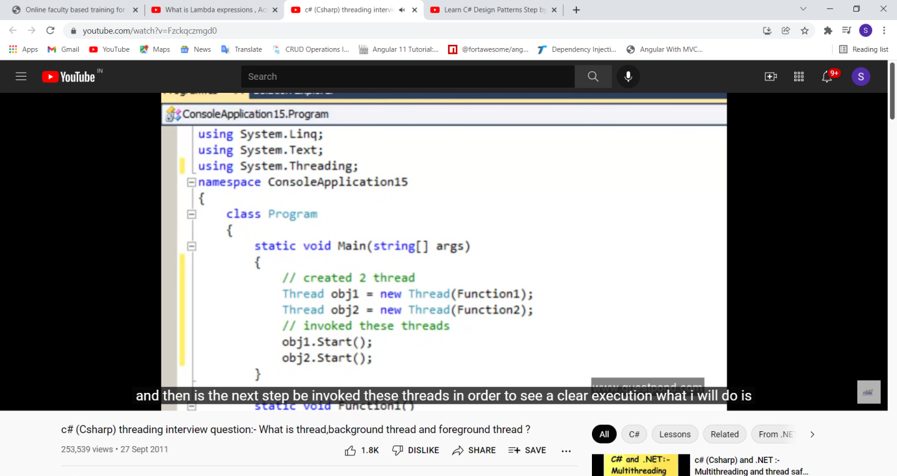

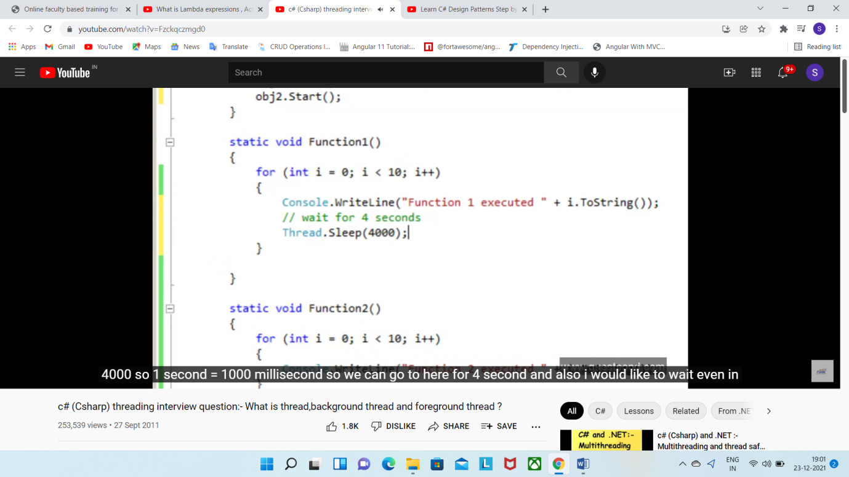

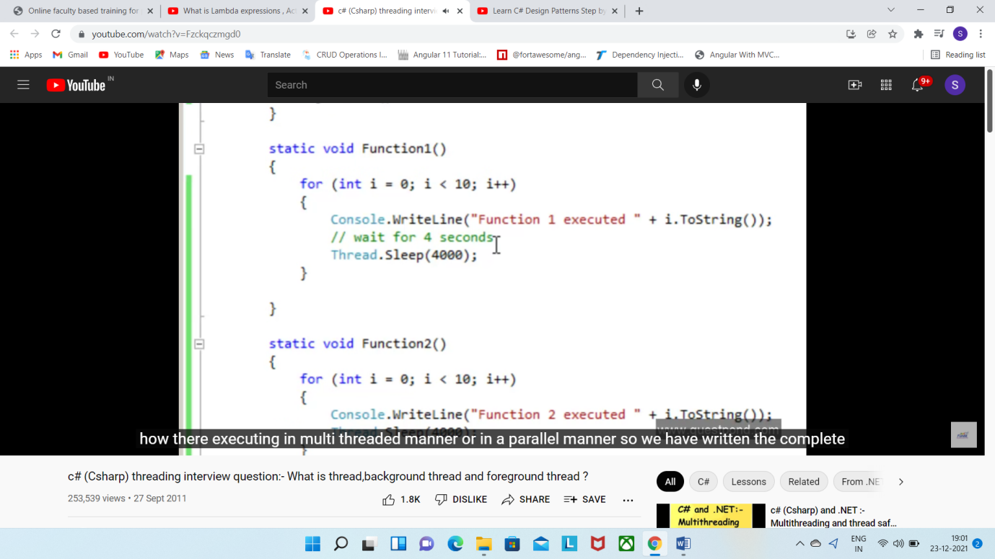

Foreground thread: above are foreground thread, which keep executing until finish, even main appl. exits

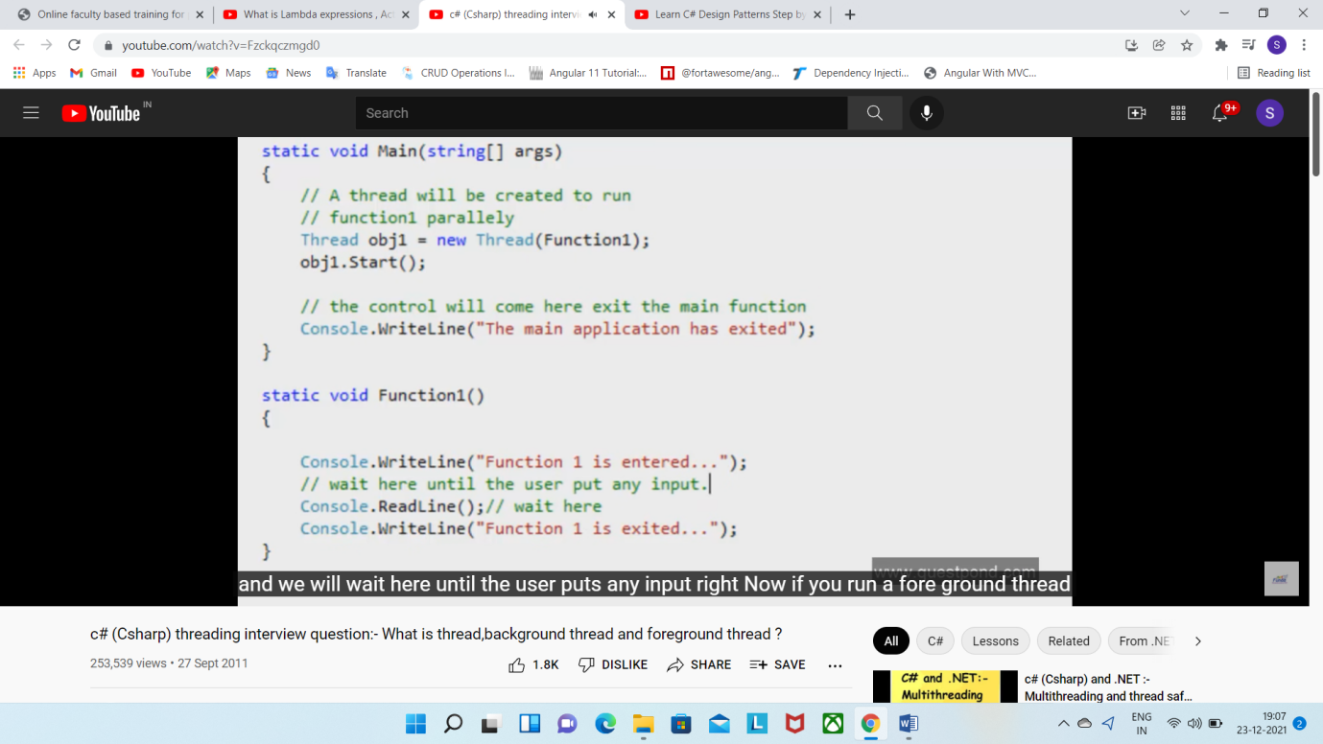

Background thread: which exit executing if main appl. Exits

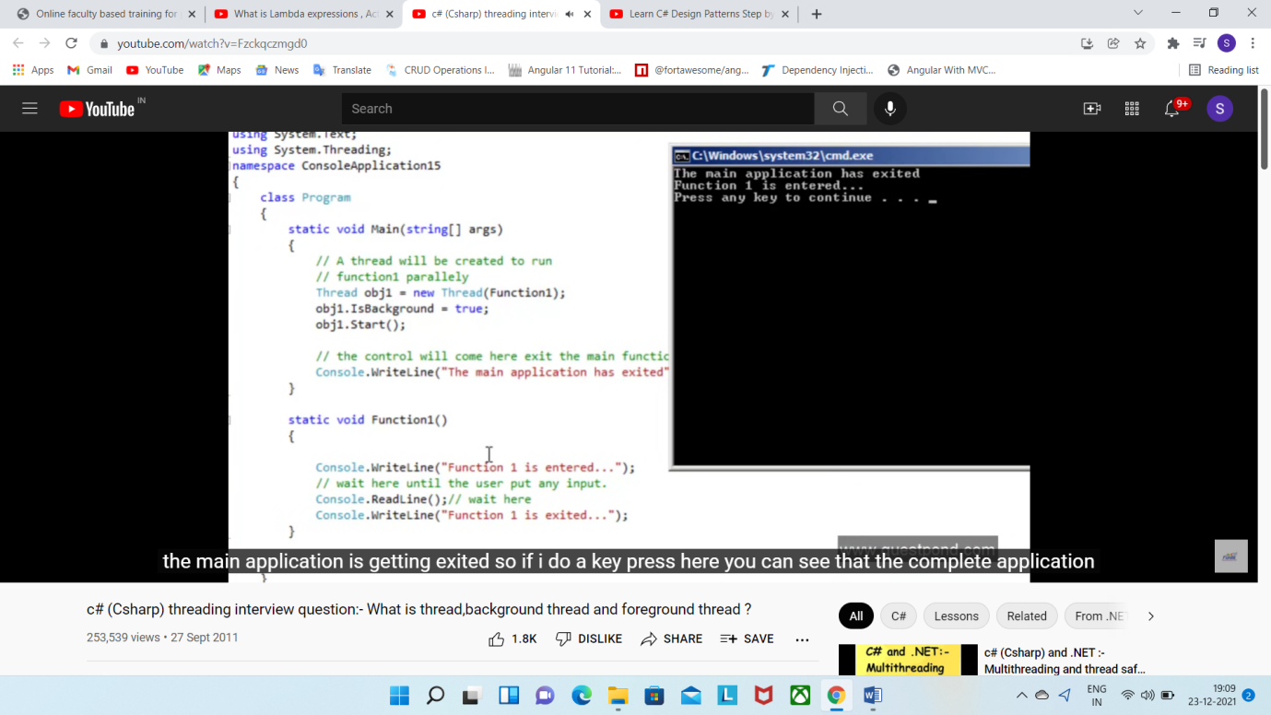

Thread Safe:->by Synchronization => only one thread execute this code at a time =>implement by

1. Lock/Monitor=>

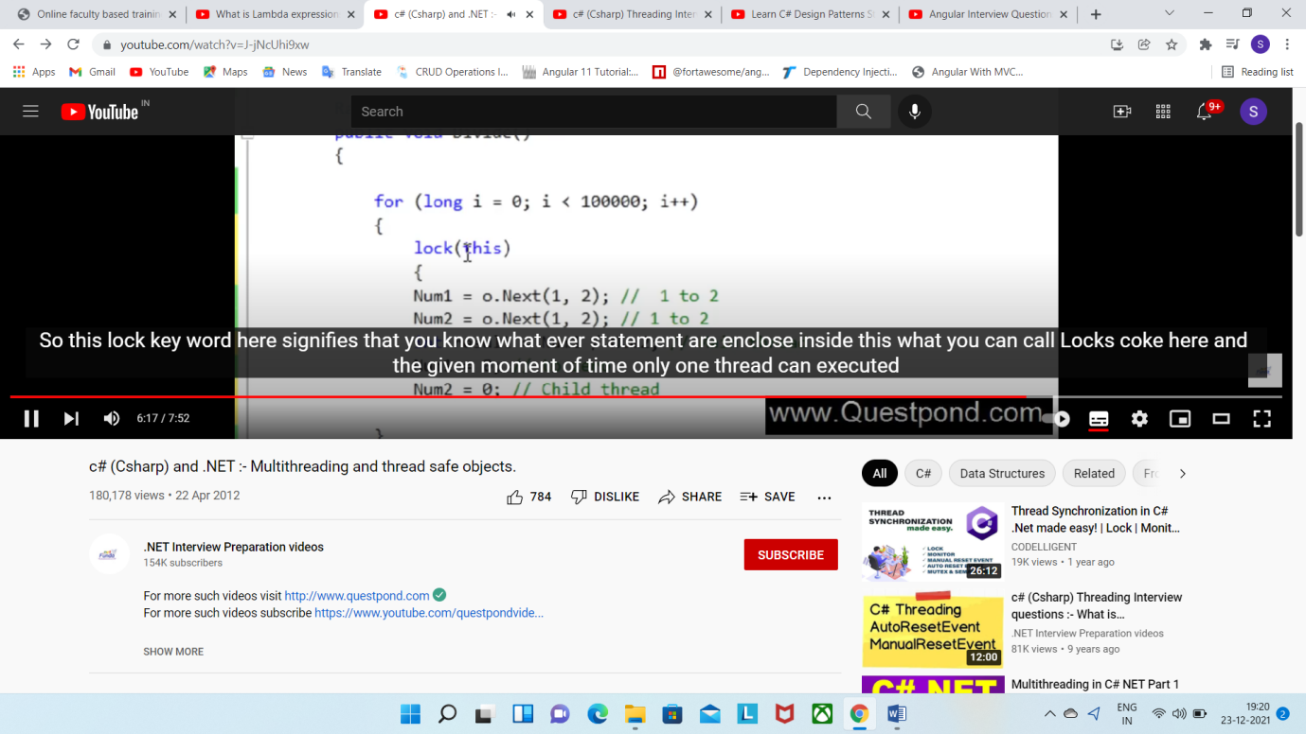

1. Mutex
2. Semaphore

# Synchronous vs Asynchronous:

synchronous: Means sequential processing, until fn1 finish fn2 not start

Asynchronous: Parallel processing

# Delegate:

It is callback to function. But why we need it we can call a fn directly,

So why we call fn indirectly by pointer

In English delegate means representative who communicate between two parties

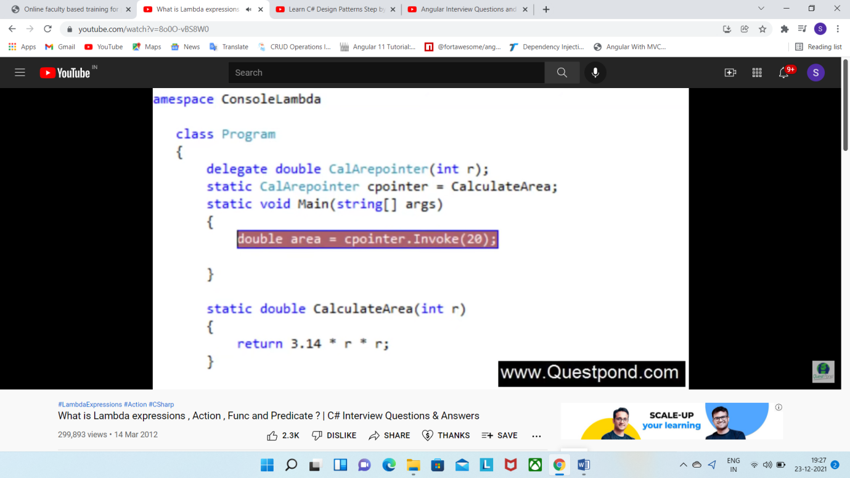

to make delegate code more simpler And to make balanced tree we use below

Anonymous method=>get rid of extra fn

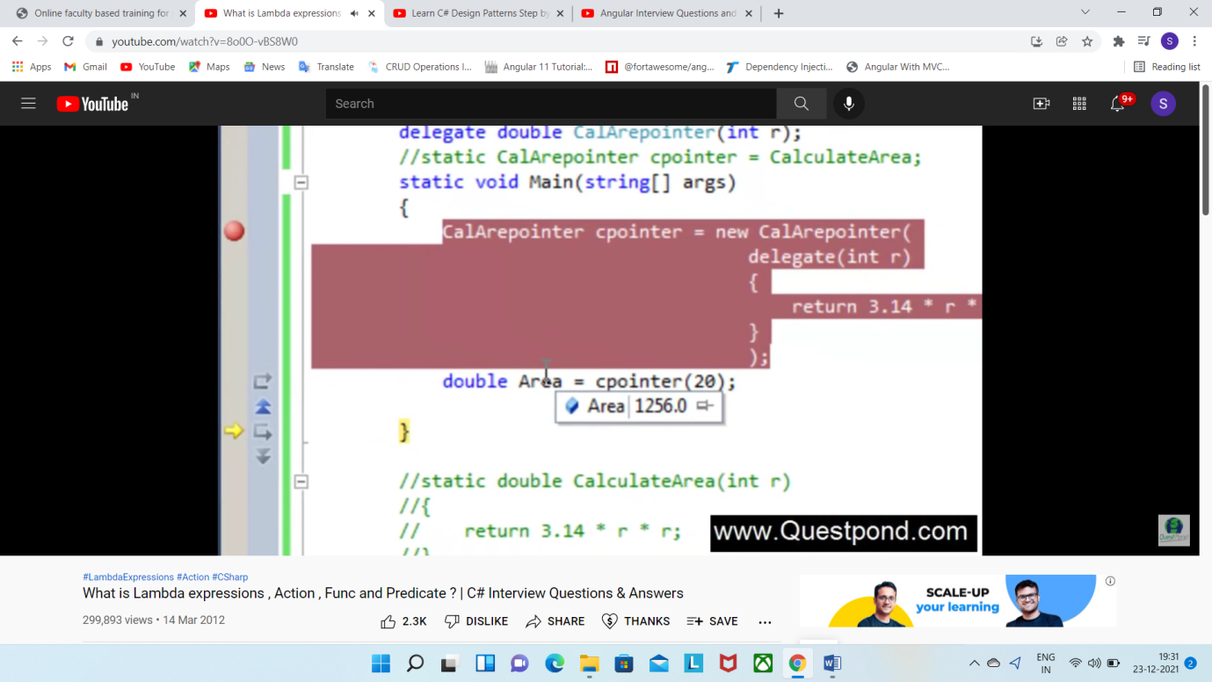

Lambda expression<> =>

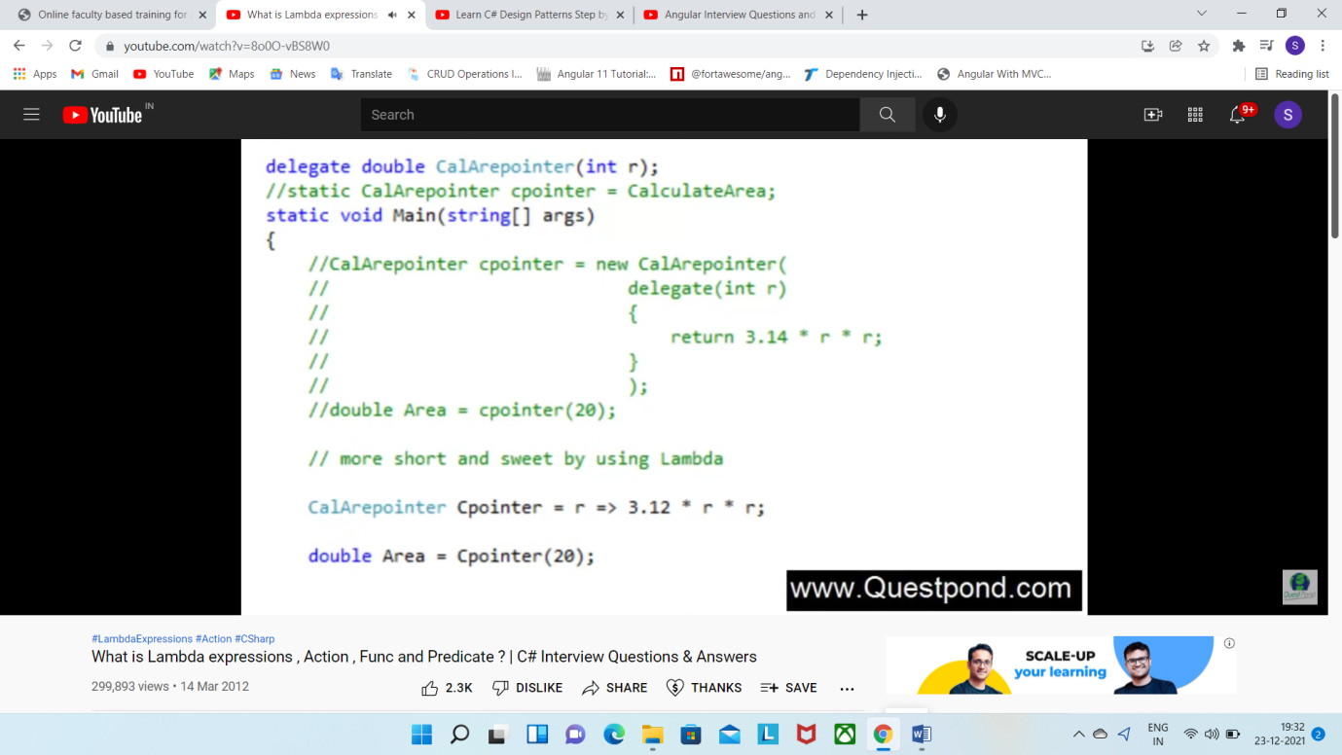

Action<> generic delegate or readymade delegate to shorten and clean code

Only input param, no output as in Func<>

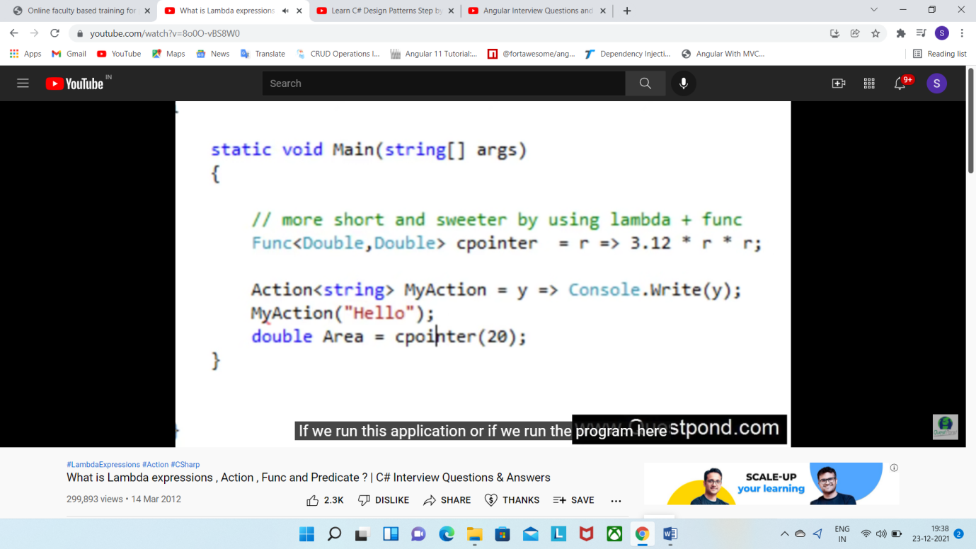

Func<> generic delegate or readymade delegate to shorten and clean code

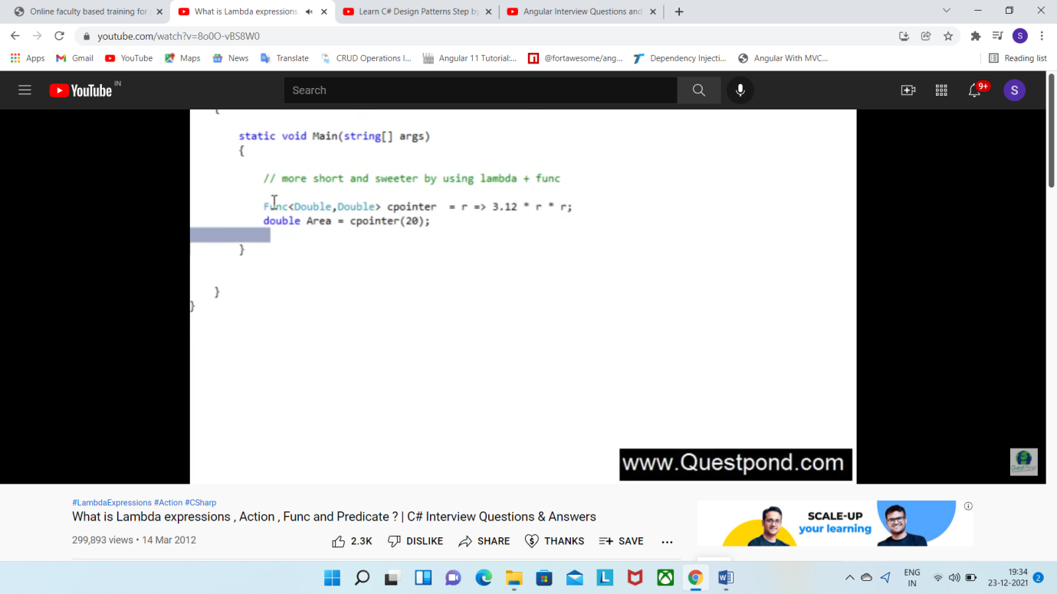

Predicate<> generic delegate or readymade delegate to shorten and clean code

It is extension to the Func<>

Only for checking purpose

Always return Boolean

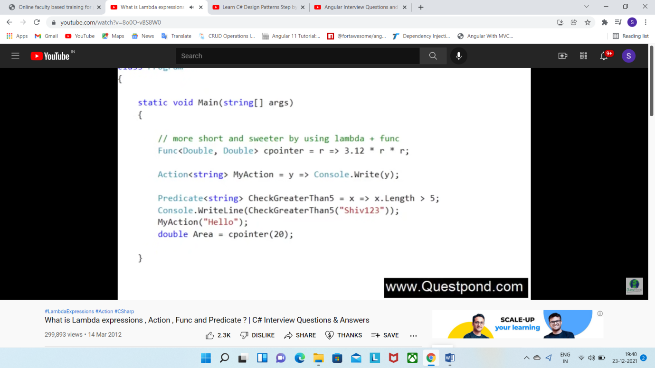

#### **Difference between Class and Structure:**

|  |  |
| --- | --- |
| Class | Structure |
| Classes are of reference types. | Structs are of value types. |
| All the reference types are allocated on heap memory. | All the value types are allocated on stack memory. |
| Allocation of large reference type is cheaper than allocation of large value type. | Allocation and de-allocation is cheaper in value type as compare to reference type. |
| Class has limitless features. | Struct has limited features. |
| Class is generally used in large programs. | Struct are used in small programs. |
| Classes can contain constructor or destructor. | Structure does not contain parameter less constructor or destructor, but can contain Parameterized constructor or static constructor. |
| Classes used new keyword for creating instances. | Struct can create an instance, with or without new keyword. |
| A Class can inherit from another class. | A Struct is not allowed to inherit from another struct or class. |
| The data member of a class can be protected. | The data member of struct can’t be protected. |
| Function member of the class can be virtual or abstract. | Function member of the struct cannot be virtual or abstract. |
| Two variable of class can contain the reference of the same object and any operation on one variable can affect another variable. | Each variable in struct contains its own copy of data(except in ref and out parameter variable) and any operation on one variable can not effect another variable. |

# Access Modifiers in C#

Access Modifiers are keywords that define the accessibility of a member, class or datatype in a program. These are mainly used to restrict unwanted data manipulation by external programs or classes. There are**4** access modifiers (public, protected, internal, private) which defines the **6 accessibility levels** as follows:

The Accessibility table of these modifiers is given below:

|  | **Public** | **protected** | **internal** | **protected internal** | **private** | **private protected** |
| --- | --- | --- | --- | --- | --- | --- |
| **Entire program** | Yes | No | No | No | No | No |
| **Containing class** | Yes | Yes | Yes | Yes | Yes | Yes |
| **Current assembly** | Yes | No | Yes | Yes | No | No |
| **Derived types** | Yes | Yes | No | Yes | No | No |
| **Derived types within current assembly** | Yes | Yes | Yes | Yes | No | Yes |

**Yield return:**

**yield** keyword will returns a result after completing of loop iterations. The [for loop](https://www.geeksforgeeks.org/for-loop-in-scala/) used buffer internally to store iterated result and when finishing all iterations it yields the ultimate result from that buffer. It doesn’t work like imperative loop. The type of the collection that is returned is the same type that we tend to were iterating over, Therefore a [Map](https://www.geeksforgeeks.org/scala-map/) yields a Map, a [List](https://www.geeksforgeeks.org/scala-lists/) yields a List, and so on.

**Syntax:**

var result = for{ var x <- List}

yield x

**extension methods:**

A C# extension methods allows developers to extend functionality of an existing type without creating a new derived type, recompiling, or otherwise modifying the original type. C# extension method is a special kind of static method that is called as if it was an instance methods on the extended type. In this article, we will create a class library and we will then extend its functionality from the caller code by implementing extension methods in C#.

## C# Extension Method

C# extension method is a static method of a static class, where the "this" modifier is applied to the first parameter. The type of the first parameter will be the type that is extended.

Extension methods are only in scope when you explicitly import the namespace into your source code with a using directive.

## Create a Class Library

Create a project Class Library project in Visual Studio.

Add the following code to the Class1. Class1 has two methods, Display and Print.

usingSystem;

usingSystem.Text;

namespaceClassLibExtMethod

{

publicclassClass1

{

publicstringDisplay()

{

return("I m in Display");

}

publicstringPrint()

{

return("I m in Print");

}

}

}

## Create a Caller Application

Now create a console application in Visual Studio using New Project. Select File > New > Project and select Visual C# and Console Application as shown below.

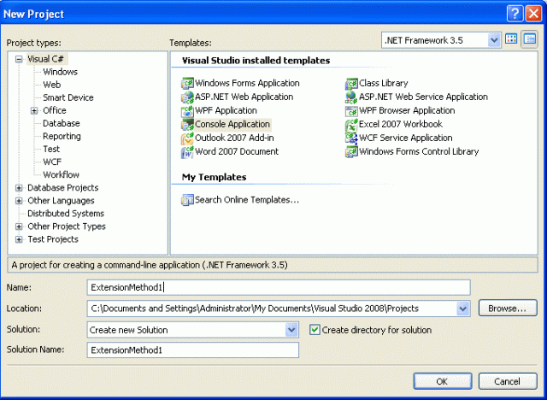

Add the reference of the previously created class library to this project.

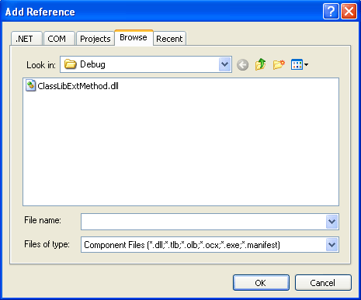

Use the following code and use the ClassLibExtMEthod.dll in your namespace:

usingSystem;

usingSystem.Text;

usingClassLibExtMethod;

namespaceExtensionMethod1

{

publicstaticclassXX

{

publicstaticvoidNewMethod(thisClass1 ob)

{

Console.WriteLine("Hello I m extended method");

}

}

classProgram

{

staticvoidMain(string[] args)

{

Class1 ob =newClass1();

ob.Display();

ob.Print();

ob.NewMethod();

Console.ReadKey();

}

}

}

In the above code, you see there is a static class XX with a method, NewMethod. If you notice, the NewMethod takes Class1 as a parameter. This is how you extend an existing library and add your own methods to it. Now, this New Method is available via the class library.

When you use Visual Studio Intellisense, you can see the extension method is represented with an arrow (different from the normal method sign), since they were instance methods on the extended type. See the figure below:

## Benefits of extension methods

* Extension methods allow existing classes to be extended without relying on inheritance or having to change the class's source code.
* If the class is sealed than there in no concept of extending its functionality. For this a new concept is introduced, in other words extension methods.
* This feature is important for all developers, especially if you would like to use the dynamism of the C# enhancements in your class's design.

More code snippets of extension expansion methods

usingSystem;

usingSystem.Text;

namespaceExtensionMethod2

{

publicstaticclassExtMetClass

{

Public static int IntegerExtension(this string str)

{

return Int32.Parse(str);

}

}

classProgram

{

staticvoidMain(string[] args)

{

string str ="123456";

int num = str.IntegerExtension();

Console.WriteLine("The output using extension method: {0}", num);

Console.ReadLine();

}

}

}

In the preceding program we have used an extension method IntegerExtension() to convert a string to a numeric type.

## Important points for the use of extension methods

* An extension method must be defined in a top-level static class.
* An extension method with the same name and signature as an instance method will not be called.
* Extension methods cannot be used to override existing methods.
* The concept of extension methods cannot be applied to fields, properties or events.
* Overuse of extension methods is not a good style of programming.

**Reflection?**

**Partial Calss?**

**https://www.geeksforgeeks.org/difference-between-method-overriding-and-method-hiding-in-c-sharp/**